**WINNERS: “Blues Artist of the Year”! (2023 Eddie Awards – Proctor’s Theater! 4/30/2023)**

**A Brilliant Combination of Classic Rock, Blues & Funk!!! Let us Entertain You!!!**

PRESS QUOTES:

**“Nite Train is back on track with their certified bluesified 7 track CD. With blues originals like “Cat on a mission”, “Stay Even”, “Love Me Baby” and “Right Where You Wanna Be” the band continues to keep the blues alive and well in the North Country.”**

**Sonny Speed, Host: Stormy Monday Blues, WRPI 91.5 FM (Troy, NY)**

**“We Loved Having You…And So Did the Audience!”**

**Jim Murphy, Director of Marketing & Corporate Relations –**

**Proctor’s Collaborative (Schenectady, NY)**

**“Nite Train has been cranking out hot sounds since 2003, but they took it to a New Level last year…The proof is on the rip-snorting disc! “**

**Greg Haymes, Albany Times Union (Albany, NY)**

**“In less than 48 hrs, Nite Train booked the event, travelled to CT and rocked! It was excellent! Courteous, professional and reasonable too…Nite Train defies gravity!”**

**Robin R. (Booking Mgr., Plantsville, CT.)**

**“This Band is Great! They really interact w/ the Crowd! I Highly Recommend Them!”**

**Ronnie B. (Booking Mgr., Manchester Center, VT.)**

Highlight Performances for Nite Train Band:

* **Proctor’s Theatre – Schenectady, NY**– “Eddie Awards” – **(4/24/2022)**
* **Turning Stone Casino – Verona, NY**–– **(11/10/2023)**
* **The Palace Theatre - Albany, NY** – “Rock 2 Rebuild” –**Katrina Relief**–**(10/15/2005)**
* **Caffe Lena – Saratoga Springs, NY – “Live Show & Simulcast” (3/6/2022 & 2/4/2023)**
* **Saratoga Flat Track – finish line gazebo – 7/31 & 9/4/2021 & 8/12/2022!**
* **Skyloft – Opening for National Act: Toronzo Cannon – 11/23/2019!**
* **Altamont Fair – Headliners for 8/16/2022, 8/14/2019, 8/15/2015, 8/17/2013, 8/12/2009, 8/19/2007!**
* **The Hollow – Blues & R-n-B Review – Albany 12/13/2018!**
* **Turkey Tap Craft Brew Fest– Times Union Center, Albany, NY! – 11/22/2014!**
* **CDPHP Workforce Challenge – Lark Tavern Sidewalk for Race! - 5/14/2014!**
* **World of Beer – Crossgates Mall – 1/2015, 9/2015, 1/2016**
* **WRPI 91.5 fm**– **6 =Live=** performances (“Stormy Monday Blues” – **Steve Daub); Last = 04/2014!**
* **Dinosaur Bar-B-Que**  “Headliners”! **(12/18/2010 & 1/28/2011, 3/2/2012, 4/21/2018, 9/15/2018. 12.7/2018)**
* **Techapalooza (9/2012) & @ EMPAC (at RPI in Troy, NY)**! **(9/22//2011)**
* **Lucky Strike – Jupiter Room – 3M Headliners - 12/8/2016!**
* **Empire State Plaza** – “Best Man” tour **- Main Stage**– **Albany, NY (08/06/2008)!**
* **SCCC Blues Festival** – “NoteworthyKidz.com” – **joined onstage by Kim Simmonds (Savoy Brown)** –**Schenectady, NY** – **(01/19/2008)!**
* **Fleet Blues Fest**– **Empire State Plaza** – **Albany, NY**– **07/2002, 2003, 2004!!!)**
* **The Egg (theatre)** – **Empire State Plaza - Albany, NY ("TechaPalooza 2003")**
* **The Leg**endary “Van Dyck” (Union Street, Stockade district, Schenectady)
* **The Nevele Grande Hotel** – Ellenville, NY (“Blues 2000 and 3” Blues Festival)
* **Revolution Hall** – **Troy, NY (Voted 2nd** Place in “Colossal Contenders” – **Round 1)**
* **Captain JP Cruises** – **Double-**Bill With “Commander Cody” (0**8/13/2004)**

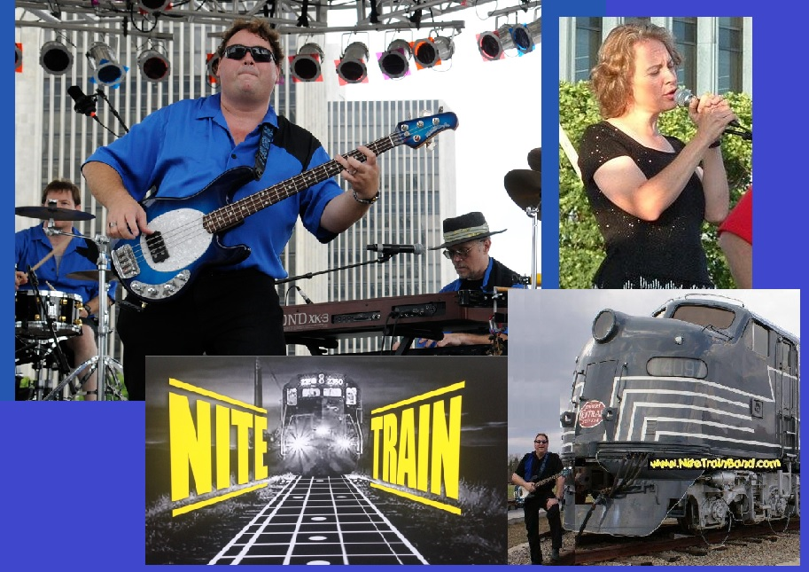

**=== Press: On March 4th 2018, Nite Train was presented with two (2) Awards from the Capital District Original Music Awards, Inc: * Best Blues Band & * Best Original Blues Lyrics !**

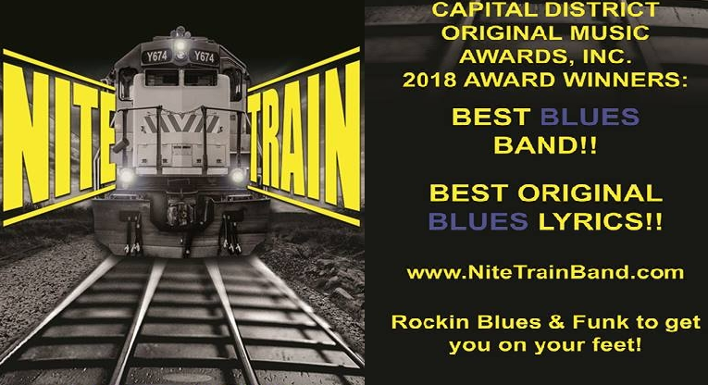

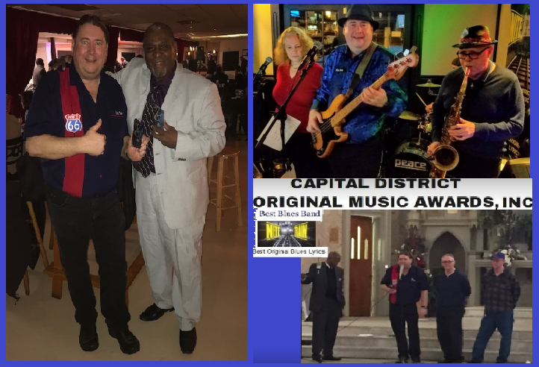

**=========================== Press (Cont’d) ======================**

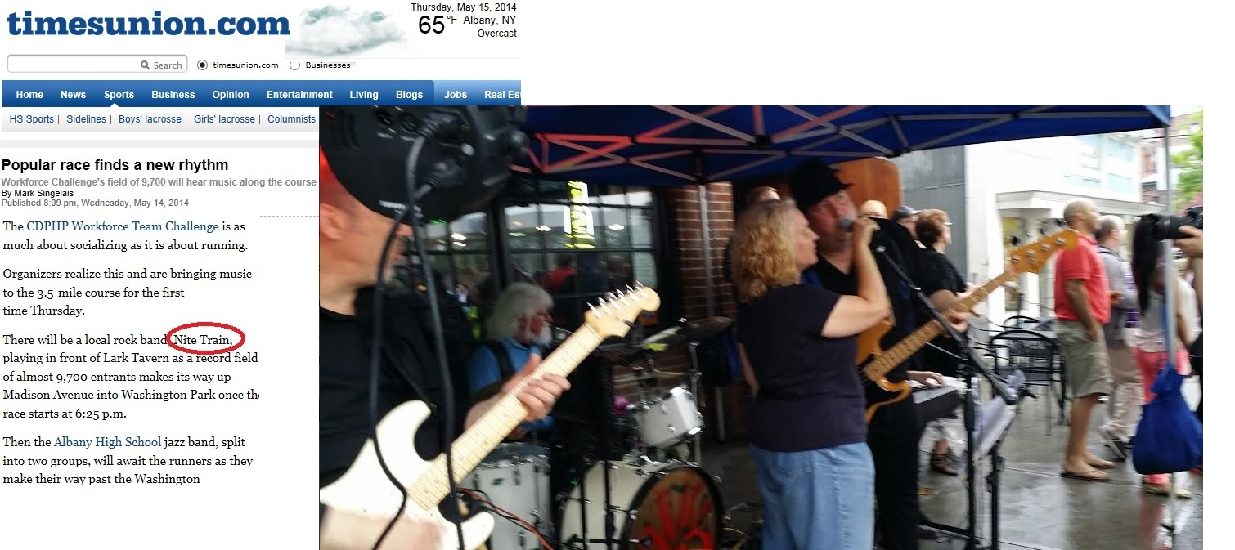



“The **Nite Train Band** with the **High Voltage Horns** celebrates the release of **"Best Man"**, their rollicking new collection of 10 original tunes that should have the dance floor hopping all night long. Led by the band's Songwriter bassist-vocalist **Ken Briggs**

…, **Nite Train** has been cranking out hot blues sounds since 2003, but they took it to a new level last year… The proof is on the **rip-snorting disc**, which was recorded at Greg "Captain Squeeze" Speck's Stonewall Studios in Rensselaerville. This is jumping stuff --

the kind of blues that definitely won't give you the blues. Party on!”. – **Greg Haymes,**

music critic, **Albany Times Union [September 27, 2007 – “Preview” section]**

**Rock2Rebuild “Quotable” from ZOX ( headliners of the R2R event ) –**

***“I dug the Nite Train’s sound and smokin’ stage presence—these guys know how to fill a***

***big room with sound and energy.”* -** Eli Miller**, vocals and guitar, ZOX**



***“Nite Train*** *plays the blues with passion and grit, exactly the way the blues should be played. If you like your blues with a bite, then climb aboard the* ***Nite Train****. It’s always a wild ride”.* - Michael Lisi, music critic, **Albany Times Union [April 2006]**

**=========================== Press (Continued) ===========================**



*The following is a review of the Main Stage appearances at Saturday, October 15, 2005* ***Rock2Rebuild*** *‘Concert for*

*Katrina Relief’ at the Palace Theater in Albany.*

Albany --- Saturday’s crowd of approximately 1,000 paying customers for the **Rock2Rebuild** benefit certainly got their $12 worth, as they witnessed a seven - act potpourri of various musical genres that all had one thing in common --- they were all very, very good. "The show began with an appearance by **Nite Train**, who earned the warm up slot by having won the “*Palace Challenge*” --- motivating their fan base to purchase the most ticket sales on their behalf. Offering up a standard guitar / harp / Hammond organ blues fare, the **Ken Briggs**-led group sandwiched one original song between four covers. Most impressive was the keyboard and saxophone work of **Marcus Benoit.**” **-** By Ronni James (aka Madam R.) **- Tech Valley Times [October, 20005 issue]**



**Rock2Rebuild – Letter from George Kansas ("Rock2Rebuild" Organizer) -**

Ken, I had actually thought a lot about the dream you had mentioned …about playing the Palace and I can relate to that very much. You guys **earned the spot** by **winning the challenge** and by the feedback I got from audience members, ***you earned it again on stage***! **You sounded great!** Thanks for putting your heart into it. I'm glad you enjoyed yourselves and I know our audience did too! Take care and I'm sure we'll see you around.

- George Kansas**, "Rock2Rebuild" , Director of Development, Palace Theatre, Albany NY**

**====== Nite Train has opened for or performed with:**

**\* Kim Simmonds** (“Savoy Brown”)

**\* Albert Cummings** (2003 - Empire State Plaza)

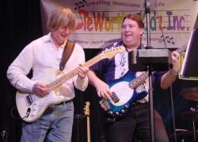

**\* Commander Cody** (and his “Lost Planet airmen”!)

**\* K.T. Tunstall** (“Black Horse & the Cherry Tree”)

**\* Hubert Sumlin** (of **Muddy Waters** / **Howlin’ Wolf** bands)

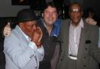

**\* ”Little Sammy” Davis** (WC Handy winner – 1997 )

**LeonRussell Ernie Williams** And have spent time personally discussing the MusicBiz with:

**\* Buddy Guy** (the “Legend”) , **\* ZZ Top**

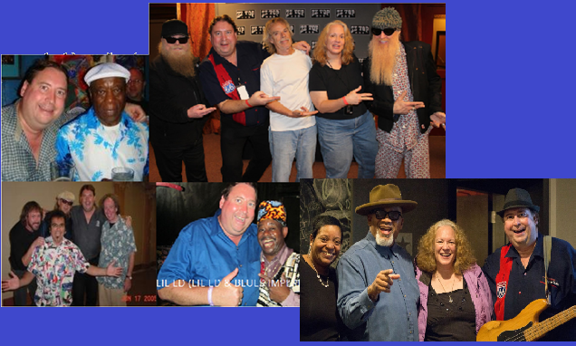

* **James Solberg -**WC Handy winner – 97 & 98 “Blues Band of the Year” and * **Lil Ed…of “Lil Ed and the Blues Imperials”** (at Rosa’s in Chicago, IL, 6/2012) * **Toronzo Cannon** (w/ Thomasina, Marla & Ken – Skyloft – 11/2019!

**====** Nite Train’s 2 A**ll-Original Compact Discs ==========**

**“Best Man” (Nite Train w/ the High Voltage Horns) – 2007**

**“Cat On A Mission” (Nite Train w/ Thomasina Winslow) - 2020**

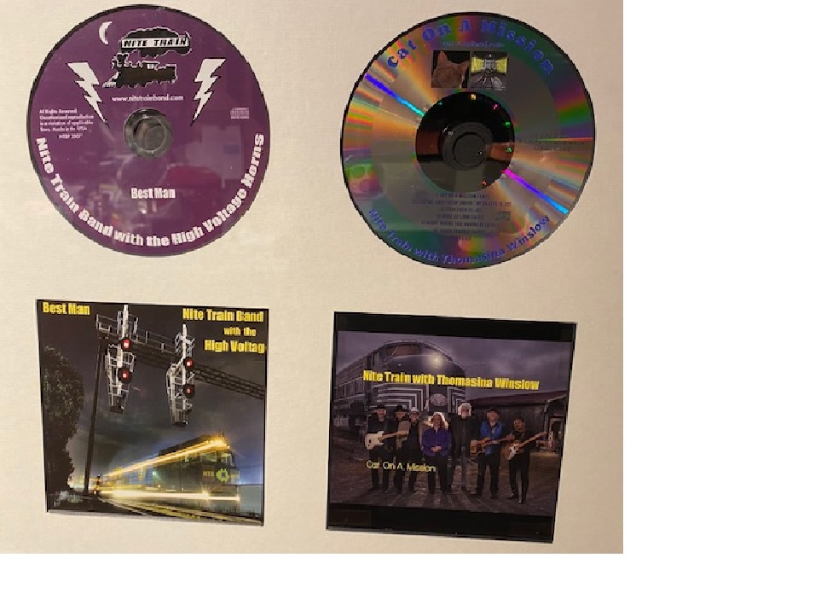



**================= For Bookings, Contact: ====================**



**Ken Briggs / Nite Train**

**(518) 320 – 4647 (cell)**

**ken.briggsy@gmail.com**